Setting Up Your Signature Block

- Update the signature block with your information. Input your name, title, department, office phone, and cell (if applicable).

- Open Outlook, and select “New Email” at the top right-hand corner of the ribbon: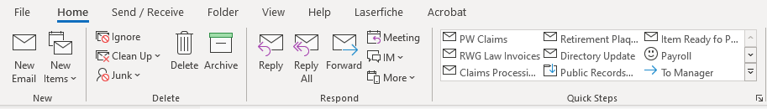

- Then select “Signature” and select “Signatures…”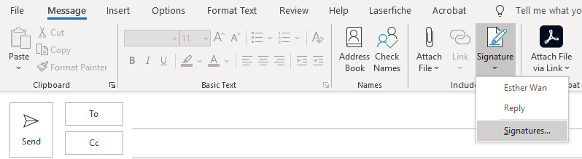

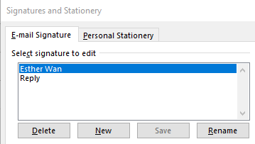
- Click on “New”

- Name your signature and copy and paste the Signature Block from step 1 (including the table) to the “Edit Signature” box. After you have copied and pasted your email to the “Edit Signature” box, click “OK,” and you are all set!
 | First Name Last Name | Title  Department | City of Fairfield  O | (707) XXX -XXXX C | (707) XXX-XXXX  1000 Webster Street Fairfield, CA 94533  www.fairfield.ca.gov  City Hall is closed every other Friday (City Hall Schedule)

CLICK AND DRAG OVER THE ENTIRE BOX TO GET BOTH TABLES

